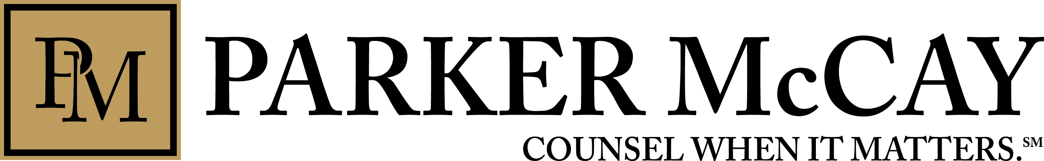

FOR IMMEDIATE RELEASE Contact: Rick Cushman
rcushman@parkermccay.com
856-985-4053
Parker McCay Recognized as Top Tier in Three Areas by U.S News & World Report

Mt. Laurel, NJ – Parker McCay is pleased to announce the firm placed three practice departments in the Best Law Firms listed by U.S. News & World Report.
The firm received a Tier I regionally ranking in Municipal Law, Medical Malpractice – Defendants, and Personal Injury Litigation – Defendants.
The submission process includes a law firm survey, client and/or professional references, and voting ballots.
To be eligible for the rankings a firm must have, “have at least one attorney who is recognized in the current edition of Best Lawyers in a "Best Law Firms" ranked practice area / metro area.”
Parker McCay has three lawyers recognized as Best Lawyers in America, a designation allotted to only the top 5% of lawyers in the country.
John C. Gillespie was recognized as a Best Lawyer in America for his work in Municipal Law. As chair of the department, John concentrates his practice in the areas of municipal law, governmental defense litigation, land use and redevelopment.
During his 42-year law career, he has represented numerous public entities and land use applicants. He regularly represents national clients in processing development applications before land use boards. He has also represented dozens of public entities in defending class action lawsuits, police liability claims, constitutional law challenges, and various other actions. He is a past President of the New Jersey Institute of Local Government.
Carolyn R. Sleeper makes the list for her work in Medical Malpractice Law – Defendants. She has represented healthcare professionals, medical institutions, and several major hospitals in a wide variety of specialty areas, including cardiology, surgery, obstetrics and gynecology, emergency medicine, family medicine, anesthesia, dentistry, psychiatry, and nursing.
She has successfully negotiated catastrophic loss cases involving death, brain damage, blindness, wrongful birth and other permanent disabilities. As a trial attorney, she has represented numerous physicians, nurses and hospital systems in and out of court. Carolyn has also appeared before the Board of Medical Examiners to represent physicians who are the subject of a Board inquiry.
Sleeper is certified by the NJ Supreme Court as a Civil Trial Attorney, a Fellow of the American College of Trial Lawyers, a member of the American Board of Trial Advocates, and a member of the Litigation Counsel of America.
Thomas M. Walsh, chair of Parker McCay’s Medical and Professional Malpractice department, is the third attorney to make the list. He is recognized under the Personal Injury Litigation – Defendants category. With the firm since 1984, Tom is one of the most well-known, and respected, malpractice lawyers in NJ.
His clients include numerous acute care health systems, subacute and long term care facilities, and healthcare professionals in a wide range of specialties such as cardiology, general surgery, neurosurgery, orthopedics, obstetrics and gynecology, emergency medicine, family medicine, anesthesia, dentistry, psychiatry, oncology, nursing, chiropractic therapy and pathology.
Tom has tried more than 100 major jury trials to verdict in the state and U.S. District courts of New Jersey and Pennsylvania. He has provided counseling in such specialties as risk management, quality assurance, director and officer liability and pre-suit adverse occurrence management. Additionally, he represents licensed health professionals in New Jersey licensing board matters. In short, he brings together a synthesis of his training, experience and an intimate knowledge of how health facilities and professionals care for their patients with one goal in mind: defending and counseling them when they need it most.
###
About Parker McCay
Parker McCay is a regional law firm serving the diverse legal needs of New Jersey clients for over 100 years. The firm provides comprehensive legal services to a wide array of clients in such specialties as public schools and education, public finance, corporate, municipal, creditors’ rights, construction, real estate, medical malpractice defense, insurance defense, commercial litigation, and employment law. Parker McCay is headquartered in Mount Laurel, N.J., with offices in Hamilton and Camden, N.J.

